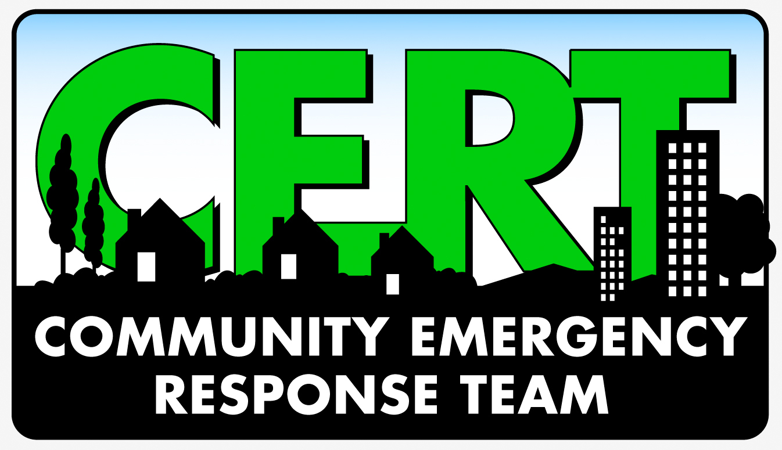

CERT Volunteer Background
Salem Fire Department - CERT
370 Trade St. SE
Salem, OR 97302
Date:
Name: |  | Former Names and/or Aliases:
Address: |  | Phone Number:
Birth Date: |  | Driver’s License Number: |  |  | State
Email Address: (legible)

What is your reason for applying to volunteer with the CERT program?

Do you have any physical or mental condition which could limit the type of activities you are able to participate in? If so, please explain:

Check all volunteer positions that you are interested in:
 | CERT Volunteer - general |  |  | CERT Medical Teams
 | CERT Communications – Amateur Radio |  |  | CERT Neighborhood Liaison
 | CERT Team Leader |  |  | CERT Steering Committee
 | CERT Safety |  |  | CERT Training Teams
What skills do you have which would help in any of the positions on a neighborhood CERT team?

Background Information:
Have you ever been arrested or convicted of any crime? If yes, please list date, location, and disposition:

I have completed the questions on this application to the best of my knowledge and have provided honest answers. I am aware that a criminal history investigation is done on all applicants and I consent to a background check for providing a CERT ID badge.

__________________________________________________
Signature Date
V 1.1 051816
Completed applications can be returned to:
Salem Fire Department, Emergency Management, CERT Program, 370 Trade St SE, Salem, OR 97302

